Sanguine
Using both the illustration and its accompanying text:
- Mark the physical characteristics of the sanguine person by highlighting them
- Mark the emotional and moral characteristics of the sanguine person by underlining them.
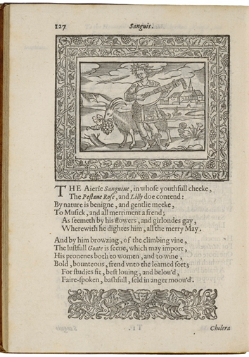
Henry Peacham, Minerva Britanna, 1612
Courtesy Folger Shakespeare Library

[Modern English Translation of the text below the illustration]

Airy Sanguine, whose youthful cheek is both pink and white, is naturally kind and gentle and humble. He loves music and all merriment, as indicated by the flowers and garlands that he decorates himself with throughout the merry month of May.

Near him are a climbing vine and a lustful goat, indicating his fondness for both wine and women. He is bold, generous, a friend to learning, fit for studies, most loving and beloved, fair-spoken, not boastful, and seldom angry.

