Toothache Drop Advertisement from 1885
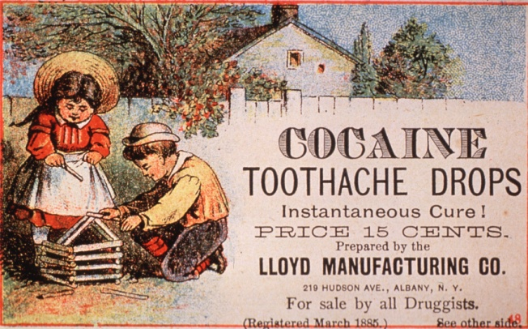 OB2033 Alt text: Advertisement with two children playing with sticks in front of a white fence
[Source: Advertisement for medicinal drops to relieve toothache, Lloyd Manufacturing Co., 1885. Courtesy National Library of Medicine]

Answer the following questions:

- When you look at this advertisement from 1885, what can you infer about some uses of cocaine at that time?
  - Whom did the advertisement target? (who would buy the product?)

  - What was the cocaine used to treat? And for whom?

  - Who endorsed the cocaine product/medicine?

- What legal status of cocaine in 1885, can you infer based on the advertisement?

- What do you think is the legal status of using cocaine as medicine today?

- Why do you think the use of cocaine differ between then and now?

